conceptual framework
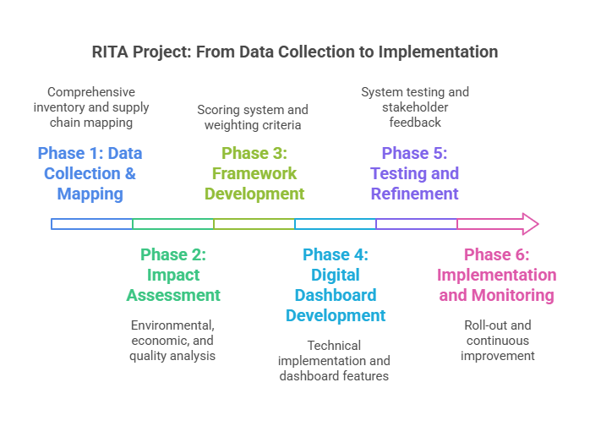

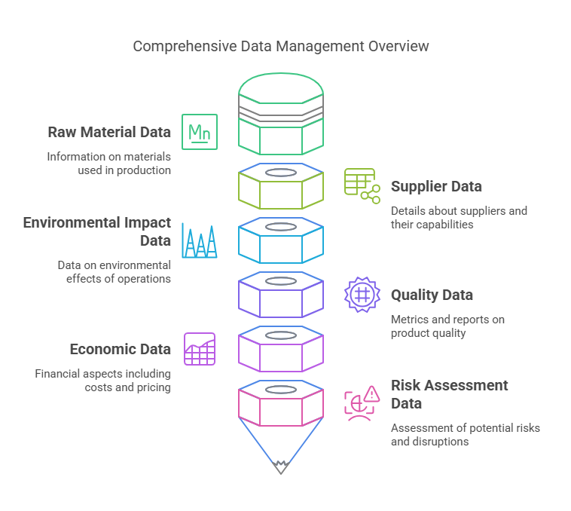

Phase 1: Data Collection & Mapping

1. Create a comprehensive inventory of:
- All raw materials currently sourced
- Current suppliers/clients for each material
- Pricing and volume data
- Quality metrics and specifications
- Current sustainability metrics

2. Map the supply chain:
- Geographic locations of suppliers
- Transportation routes, modes, and food miles including reception dynamics
- Storage/warehousing locations
- Key intermediaries or processors before reception if any

Phase 2: Impact Assessment

1. Environmental Impact Analysis:
- Carbon footprint calculation for each supplier and specified transportation route or dynamics
- Water footprint
- Land use impact
- Energy use
- Waste generation (if any)
- Toxicity impacts (Human carcinogenic, human non-carcinogenic, ecotoxicity)

2. Economic Analysis:
- Direct costs of materials
- Transportation and logistics costs
- Storage costs
- Quality-related costs (testing, rejections, rework)
- Regulatory or other supply costs

3. Quality Assessment:
- Define key quality parameters for each material
- Historical quality performance data
- Impact of quality variations on final product

Phase 3: Framework Development

1. Create a INDICATOR scoring system that integrates:
- Environmental performance metrics
- Economic metrics
- Quality metrics
- Risk factors

2. Develop weighting criteria for different factors based on:
- Company priorities
- Industry standards
- Regulatory requirements
- Customer expectations

Phase 4: Digital Dashboard Development

1. Technical Implementation:
- Select appropriate technology stack
- Design database architecture
- Create data pipelines for regular updates
- Implement security measures

2. Dashboard Features:
- Real-time monitoring of key metrics
- Predictive analytics for future scenarios
- Trade-off analysis tools
- Comparative interface
- Alert systems for key thresholds
- Reporting capabilities

Phase 5: Testing and Refinement

1. System Testing:
- Data accuracy verification
- User interface testing
- Predictive model validation
- Performance testing

2. Stakeholder Feedback:
- User acceptance testing
- Training sessions
- Feedback collection
- System refinement

Phase 6: Implementation and Monitoring

1. Roll-out Plan:
- Phased implementation strategy
- Training program
- Change management plan
- Communication strategy

2. Continuous Improvement:
- Regular review of metrics
- System updates and refinements
- Incorporation of new sustainability criteria
- Expansion of supplier assessment

SPECIFIC DATA REQUIREMENTS BREAKDOWN

1. Raw Material Base Data
- Complete list of raw materials used
- Annual consumption volumes
- Material specifications
- Current supplier list
Questions to ask:
- What are all the raw materials currently used in production?
- What are the technical specifications required for each?
- What is the annual consumption/demand pattern?
Source: Internal ERP/MRP systems, Procurement records, Material specification documents

2. Supplier Data
- Geographic locations
- Transportation route and modes
- Production capacity
- Certifications held
- Historical supply performance
Questions to ask:
- Where are all current suppliers located?
- What sustainability certifications do they hold?
- What is their production capacity and utilization?
- What is their track record of delivery performance?
- How are products transported or handled from supplier to the final reception
Source: Supplier questionnaires, Site visits, Third-party verification reports

3. Environmental Impact Data
- Global warming potential
- Land use
- Water consumption
- Human Toxicity
- Ozone depletion
- Particulate matter formation
Source: Environmental impact assessment, Environmental audits/reports, Supplier sustainability reports

4. Quality Data
- Historical quality performance metrics
- Test results and certificates of analysis
- Rejection rates and reasons
- Quality-related customer complaints
Questions to ask:
- What are your quality control processes?
- Can you provide historical quality performance data?
- What is your process for handling quality deviations?
Source: Quality management system records, Lab test reports, Customer feedback systems

5. Economic Data
- Direct material costs
- Transportation costs:
* Mode of transport
* Distance
* Fuel costs
* Handling costs
- Storage costs
- Quality control costs
- Compliance costs (Regulatory costs)
Questions to ask:
- What is the raw material pricing structure?
- How do transportation costs vary by season/volume?
- What are the additional costs for sustainability initiatives or regulatory compliance?
Source: Financial records, Logistics contracts, Warehouse records

6. Risk Assessment Data
- Supply chain disruption history (Understand historical disruptions by each supplier)
- Political stability in source regions
- Regulatory compliance status
- Supplier’s sustainability status
Questions to ask:
- What backup supply options exist?
- How vulnerable is production to climate events?
- What regulatory changes might affect supply?
Source: Risk assessment reports, News monitoring, Regulatory databases

Data Collection Strategy:

1. Internal Data Collection:
- Review existing systems (ERP, QMS, etc.)
- Identify data gaps
- Set up data collection processes for missing information

2. Supplier Engagement:
- Develop comprehensive supplier questionnaire
- Schedule supplier audits
- Create supplier portal for regular data updates

3. Third-Party Data:
- Identify reliable third-party data sources
- Subscribe to relevant databases
- Engage certification bodies

4. Validation Process:
- Cross-verify data from multiple sources
- Establish data quality metrics
- Set up regular data verification procedures

5. Data Management:
- Create central database
- Establish data update frequency
- Define data access protocols
- Set up data backup procedures

Data Quality Questions to Consider:
- How recent is the data?
- How was it measured/collected?
- What verification methods were used?
- What are the margins of error?
- How frequently can it be updated?
Would you like me to elaborate on any of these areas or provide specific templates for data collection tools?

